# Assignment 2

**IMPORTANT NOTE: NO LATE SUBMISSIONS WILL BE ACCEPTED FOR THIS ASSIGNMENT**

## Game Search

### Problem 1

**Max: [4308: 25 Points, 5360: 20 Points]**  
  
Draw the full Minmax tree for the game of TicTacToe starting from the given game state. Calculate the minmax value of every node and what the optimal action for the MAX player (X) to take is. (Note: Winning results in a payoff of +1 and losing a payoff of -1)

|  |  |  |
| --- | --- | --- |
| X | O | X |
|  | X |  |
| O |  | O |

Figure 1: A TicTacToe Game State.

### Problem 2

**Max: [4308: 30 Points, 5360: 20 Points]**

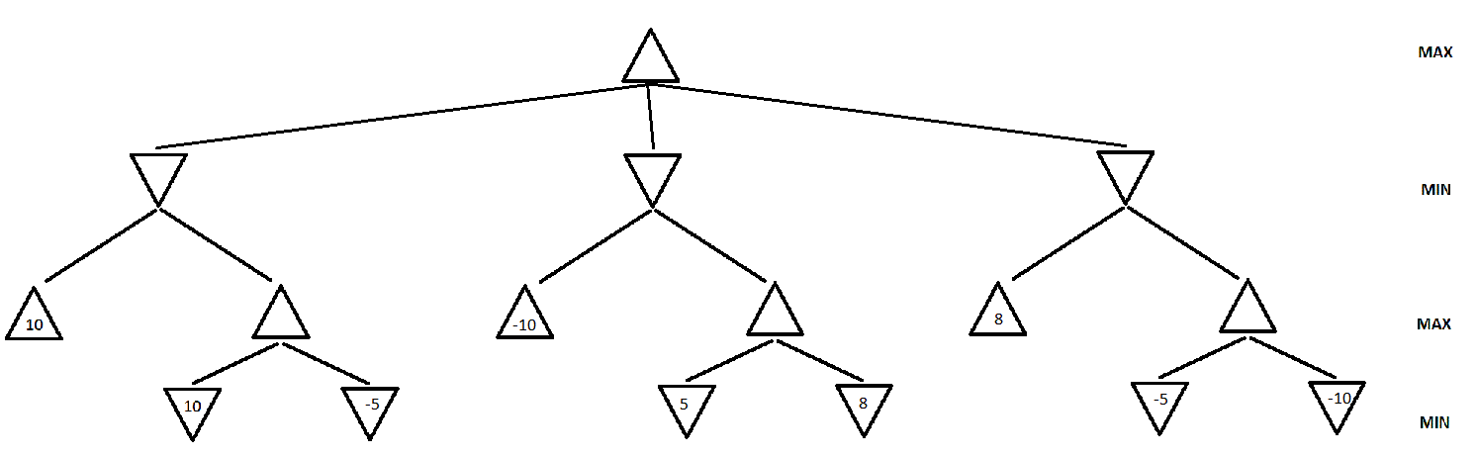  
  
Figure 2. A game search tree.

a. In the game search tree of Figure 2, indicate what nodes will be pruned using alpha-beta search, and what the mimax values are for the rest of the nodes. Assume that, when given a choice, alpha-beta search expands nodes in a left-to-right order. Also, assume the MAX player plays first. Finally incidcate which action the Minmax algorithm will pick to exectute.

b. This question is also on the game search tree of Figure 2. Suppose we are given some additional knowledge about the game: the maximum utility value is 10 and the minimum utility is -10, i.e., it is not mathematically possible for the MAX player to get an outcome greater than 10 or lesser than -10. How can this knowledge be used to further improve the efficiency of alpha-beta search? Indicate the nodes that will be pruned using this improvement. Again, assume that, when given a choice, alpha-beta search expands nodes in a left-to-right order, and that the MAX player plays first.

### Problem 3

**Max: [4308: 20 Points, 5360: 20 Points]**

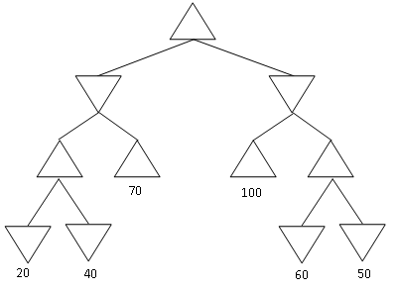  
Figure 3: Yet another game search tree

Consider the MINIMAX tree above. Suppose that we are the MAX player, and we follow the MINIMAX algorithm to play a full game against an opponent. However, **we do not know what algorithm the opponent uses**.

Under these conditions, what is the best possible outcome of playing the full game for the MAX player? What is the worst possible outcome for the MAX player? Justify your answer.

NOTE: the question is not asking you about what MINIMAX will compute for the start node. It is asking you what is the best and worst outcome of a **complete game** under the assumptions stated above.

### Problem 4

**Max: [4308:25 Points, 5360: 20 Points]**

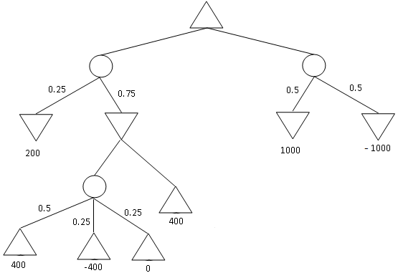  
Figure 4: An Expectiminmax tree.

Find the value of every non-terminal node in the expectiminmax tree given above. Also indicate which action will be performed by the algoirithm.  
What does the MinMax value obtained by the root node represent. For a particular game, what is the maximum and minmum actual payoff the MAX player can get if MIN plays the optimal strategy (according to Expectiminmax). What if the opponent plays a random strategy?

### Problem 5 (Extra Credit for 4308, Required for 5360)

**Max: [4308: 20 Points EC, 5360: 20 Points]**  
  
Suppose that you want to implement an algorithm tht will compete on a two-player deterministic game of perfect information. Your opponent is a supercomputer called DeepGreen. You do not know what algorithm DeepGreen uses. You are given a library function DeepGreenMove(S), that takes any state S as an argument, and returns the outcome of the move that DeepGreen will choose for that state S (more precisely, DeepGreenMove (S) returns the state resulting from the opponent's move).

Write an algorithm in pseudocode (following the style of the Minimax pseudocode) that will always make an optimal decision given the knowledge we have about DeepGreen. You are free to use the library function DeepGreenMove(S) in your pseudocode. How does this compare to Minimax wrt optimality of solution and the number of states explored.

## How to submit

The assignment should be submitted via [Canvas](https://uta.instructure.com/). Scan or Type the solutions for all the other Tasks together and create a single pdf titled *assignment2_<net-id>.pdf*.

## Submission checklist

Are the solutions to remaining tasks in a pdf file titled assignment1_<net-id>.pdf? (where <net-id> is replaced with your net id)  
Did you upload the file on the submission page in [Canvas](https://uta.instructure.com/) and then click on 'Submit Assignment' to ensure that a submission is made?